Young Parent Tip Sheet for Home Visitors
- Treat them with the same respect that you would have for any parent
- Be mindful of your language, use “Young Parent or Parent” rather than “Teen”, which infers inferiority and holds stereotypes
- Always assume they are parenting with the best of intentions, use the FAN, refrain from “dumping” unsolicited information on them, ask permission first, use collaborative exploration to get to strategies together
- Be positive about their strengths and goals as both parent and individual
- Young parents are up against the stigma that they have “ruined their lives” which can be extremely damaging to the parent, instead be a mentor and help uncover their strengths and capacities
- When setting goals in collaboration with families, be mindful of common barriers young parents face such as transportation, childcare, education, social supports and housing.
- Support parents to apply what they are learning through outside resources, parenting classes, and curriculum in ways that are meaningful and compliment their learning styles
- Include young fathers in your programs and conversations, also be mindful of your approach with extended family members
- Often efforts are focused on the mother and child, but be mindful of including the father in conversations, supports, extending resources, checking in on their mental health. Include them in planning and decision-making with their families
- Treat each young parent individually, exploring their specific needs and be flexible
- Understand the unique challenges that expectant and parenting teens are up against (childcare, transportation, financial resources, financial literacy/management skills, inconsistent methods of communication, self-care skills, school schedules)
- Home Visitors may need to meet during or around school hours, in public locations such as parks, libraries, coffee shops, or tagging onto already existing appointments (WIC, OB/GYN, ISD)
- Explore with the parent alternative ways to communicate and connect, i.e. telehealth, FaceBook Messenger, Instagram, FaceTime, etc.
- Home Visitors may want to get permission to contact other family members or friends when/if their means of communication becomes unavailable
- Always take a diversity-informed approach, be aware of intersecting identities (race, sexual orientation, gender identity, immigration status, religion, etc.) as these can affect outcomes
- It is important to practice humility with all families, specifically young parents and be patient with the relationship building process. Take time to get to know who they are individually, respect their diversity and refrain from making assumptions about their relationships, circumstances of their pregnancy, etc.
- Be mindful of your own judgments, implicit biases and assumptions made about their circumstances
- When in doubt, always use the FAN. How are you practicing your Mindful Self-Regulation skills in Home Visits, what are your strategies to stay grounded to the present moment and attuned to the parent? Ask yourself “what am I carrying with me in my invisible backpack?” and using reflective supervision to work-through possible activations that arise
7. Ideas for Recruiting Young Parents:
- Create Young Parent Support Groups (virtually, in-person)
- Word of mouth- have a client invite an eligible friend to a visit, really let them get the experience of Home Visiting
- Young parent testimonials

- Build relationship with local Homeless Young Shelter- offer to facilitate classes, outreach, support group, belly casts, and refer to community resources
- Collaborate and do outreach/education with High School Social Workers, Nurses, Teachers, GRADS Programs, WIC/County Health Offices, Youth Shelters, etc.
Our Words Matter…

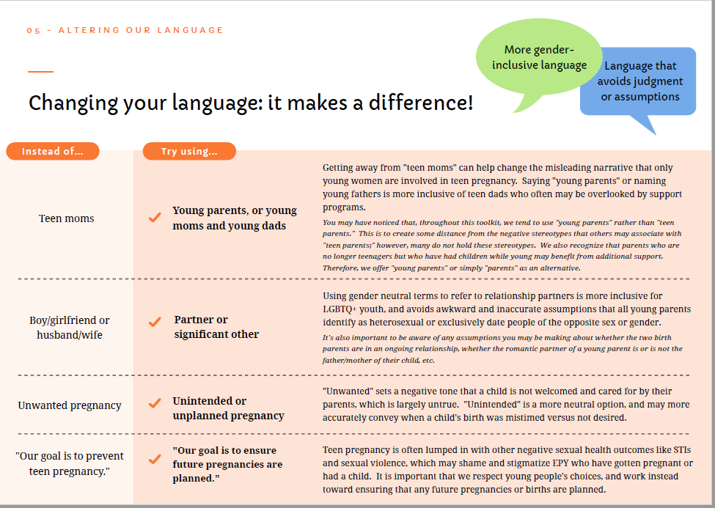

References
Strategies for working with young parents. Supporting Young Parents Toolkit - ACT for Youth. (n.d.). Retrieved January 10, 2022, from http://actforyouth.net/youth_development/professionals/yp/strategies.cfm

