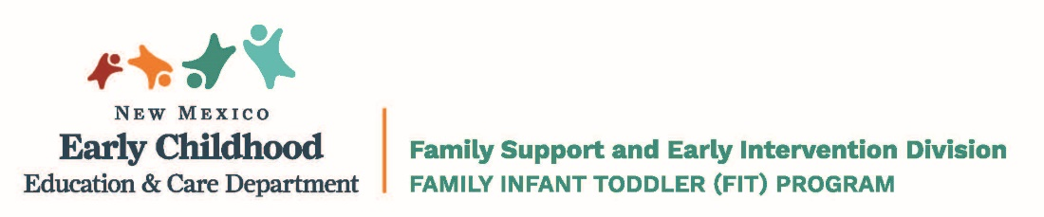

FREEDOM OF CHOICE

Date: __________________

Dear: _________________________________

Family Support and Early Intervention Division Family Infant Toddler Program Service Definitions & Standards require that families be notified of their right to choose a provider agency, when more than one provider is available in their county.

Please select one of the following FIT providers by checking the box (X) next to the agency’s name. Your service coordinator can help you understand your choices.

County: ____________________________

 | Provider Agency Name: | Location: | Telephone Number:

Child Name: __________________________________ DOB: ____________

_____________________________________________ ________________
Parent/Guardian Signature Date

______________________________________________ ________________
FSC Signature Date

