Systematic Instruction 7
Prompting (Shaping & Fading)

What is Prompting?

Response Prompts:

Types of Response Prompts:
1.
2.
3.
4.
5.

Stimulus Prompts:

Fading:

Shaping:

Prompting Hierarchy

1.

2.

Prompting Hierarchy: Prompts:
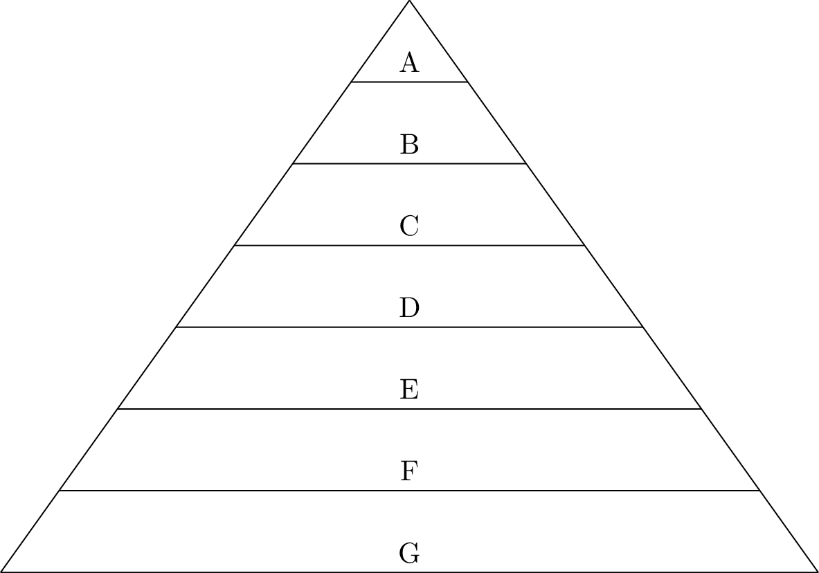
A.
B.
C.
D.
E.
F.
G.

The most intrusive prompt is:
The least intrusive prompt is:

Response Prompts
Response prompts are designed to:

1. Physical:
a.

b.

2. Modeling:

3. Visual/Written:

4. Verbal:

5. Gestural:

Stimulus Prompts:
Change the _______________________ to help the student ______________
____________________________________________.

- Position & Size

- Fading

Stimulus Prompts Examples:

Time Delay:

Using Prompts:
How we use prompts depends on:
1.
2.

Level of learning and prompts:
- Acquisition

- Proficiency/Fluency Building

- Maintenance:

- Generalization:

How to use prompt in a systematic way:

Prompting Hierarchy:
1.

2.

Incorrect Responses:
1.
2.
3.
4.

Prompt Dependency:
How do you recognize it?

What do you do about it?
1.

2.
a.
b.
c.
d.
e.
f.
g.
h.

3.
4.

This prompt does not always need to be faded:
(This is a good step between prompt dependence and independence)

This prompt must be faded:

Prompting is for _____________________________ not for ___________________________________.

- Reflection

- Things I learned from this module:

- Questions I have:

- Things I would like to learn more about:

Putting it into practice:
- Identify one stimulus prompt (that goes with the stimulus) that you use in the classroom.

  - How are you fading it?

- Identify one response prompt (that helps the learner respond correctly) that you use in the classroom?

  - Does it need to be faded?

- Chances are that you use more stimulus than response prompts. Identify additional response prompts you might use.

- Identify ways in which you use the following prompts or specify the reasons that you don’t use certain prompts (e.g. physical prompts provoke aggressive responses).
  - Physical (full and partial)
  - Visual
  - Verbal
  - Gestural
  - Modeling

- What kind of prompts do you need to use more and what kind do you need to use less?

- For at least one of your students, describe how you will use prompting to increase the student’s ability to perform a skill independently.

- Is there a student who is “prompt dependent?” Make a plan for reducing prompt dependence.

- Almost all of us have behaviors that are being shaped. (Working with the “Articulate Powerpoint program” is being shaped for me – through trial and error. What is a classroom behavior that you would like to shape? Where will you start and how will you chain the behavior?

For questions regarding content and practice, contact:
School Services
Autism and Other Developmental Disabilities Program
Center for Development and Disability
University of New Mexico
CDD-SchoolServices@salud.unm.edu
505.272.1852 or 1.800.270.1861

